**What is PagerDuty?**

Through its SaaS-based platform, PagerDuty empowers developers, DevOps, IT operations and business leaders to prevent and resolve business-impacting incidents for exceptional customer experience. When revenue and brand reputation depends on customer satisfaction, PagerDuty arms organizations with the insight to proactively manage events that may impact customers across their IT environment. With hundreds of native integrations, on-call scheduling and escalations, machine learning, business-wide response orchestration, analytics, and much more, PagerDuty gets the right data in the hands of the right people in real time, every time.

**There are two ways for users to log into PagerDuty; depending on your account’s configuration, one or the other may not be available:**

* Log in Using Email and Password

**Log in Using Email and Password**

1. In a supported web browser, navigate to your PagerDuty account’s login URL (i.e., https://identity.pagerduty.com) or open the PagerDuty mobile app and tap Sign In.

* If prompted, tap or click Continue in the confirmation modal.

1. Enter the email address associated with your PagerDuty account and click or tap next.
2. Enter your password and click or tap Sign In.

* If your email address is associated with more than one PagerDuty account, you’ll be presented with a list of accounts. Select the account you wish to sign into from the list.

**Navigate the Incidents Page**

The Incidents page is the main screen that appears when you first log in to your PagerDuty account. You can navigate to this page from other screens by clicking Incidents in the top menu.

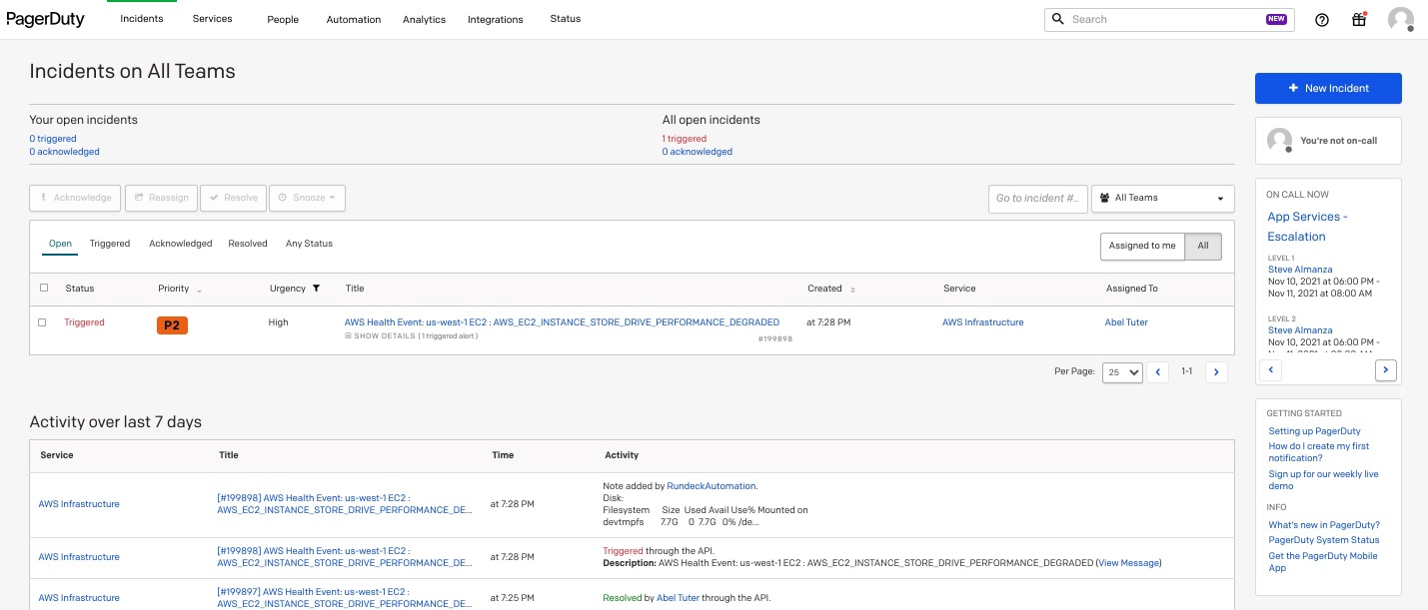

**Incidents on All Teams**

The top of the dashboard shows any triggered or acknowledged incidents currently active in the account. In the example below, there is currently 1 triggered incident and 1 acknowledged incident in PagerDuty. Your open incidents will show triggered and acknowledged incidents specifically assigned to you, and all open incidents will show a total of all triggered or acknowledged incidents in the PagerDuty account. If there is a triggered incident, the text will be red, and if there is an acknowledged incident the text will be orange. If there are no open incidents, the text will remain blue.

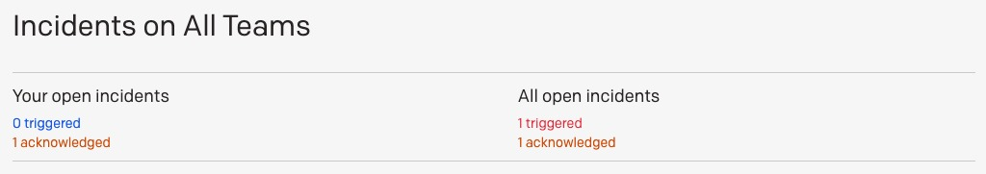

Just below this module, you will be able to see details of specific incidents that are assigned to you, as well as all incidents within PagerDuty.

* To view incidents assigned to you specifically, click Assigned to me.
* To view all incidents in PagerDuty, click all.
* To filter incidents by their status, select Open, Triggered, Acknowledged, Resolved, or Any Status.
* To take action on an incident, select the checkbox to the left of the incident and then click the Acknowledge, Reassign, Resolve, Snooze or Merge Incidents buttons.

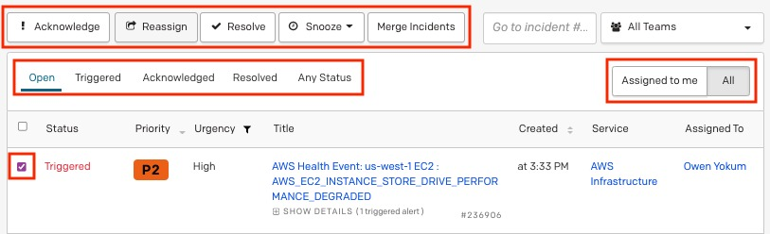

**High and Low Urgency Incidents**

Urgency levels can be configured to notify you based on your notification rules.

In the PagerDuty incident dashboard, incident urgency is indicated in the Urgency column. High-urgency incidents will be displayed at the top, followed by low-urgency incidents. This helps you quickly identify the most critical incidents.

In the example below, incident #4728 was triggered most recently, but because it’s low-urgency, it’s displayed below the high-priority incidents. 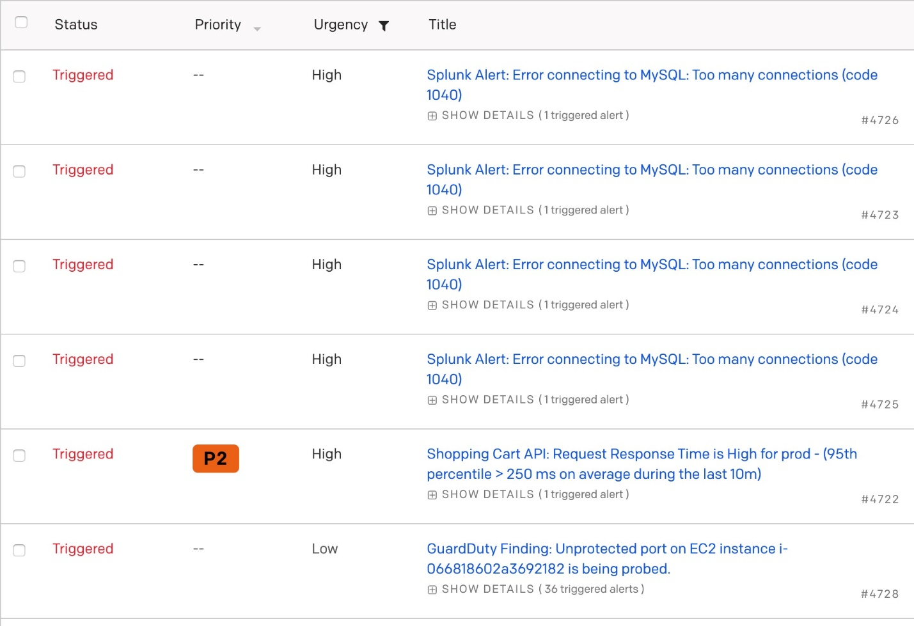

Incidents will maintain this urgency-based order, even after acknowledgment. In the example below, both incidents are acknowledged. The high-urgency incident remains at the top of the table, followed by the low-urgency incident.

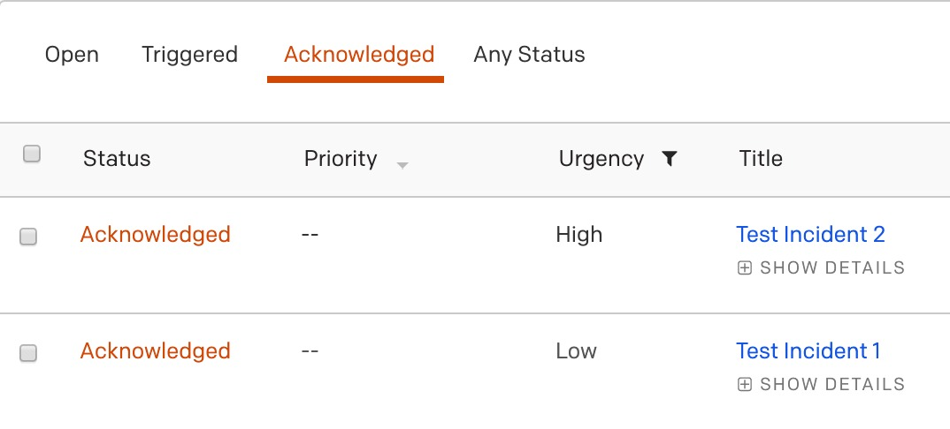

**Incidents**

An incident represents a problem or an issue that needs to be addressed and resolved. Incidents trigger on services, and a service’s escalation policy prompts notifications to go out to on-call responders to remediate the issue.

**Incident Statuses**

* Triggered: An active [service](https://support.pagerduty.com/docs/services-and-integrations) (i.e., someone is on call and the service is not disabled or in maintenance mode) will trigger an incident when it receives an event. The incident will escalate according to the service's [escalation policy](https://support.pagerduty.com/docs/escalation-policies). By default, PagerDuty sends [notifications](https://support.pagerduty.com/docs/notifications) when an incident is triggered, but not when it is acknowledged or resolved. Users create their own [notification rules](https://support.pagerduty.com/docs/configuring-a-user-profile#notification-rules) — or they can use [webhooks](https://developer.pagerduty.com/docs/ZG9jOjQ1MTg4ODQ0-overview" \t "_self) — to receive notifications when an incident is acknowledged or resolved.
* Acknowledged: An acknowledged incident is being worked on, but is not yet resolved. The user that acknowledges an incident claims ownership of the issue, and halts the escalation process. While an incident is acknowledged, notifications are not sent until the [acknowledgement timeout](https://support.pagerduty.com/docs/configurable-service-settings#acknowledgement-timeout) is reached. If the acknowledgement timeout is reached, the incident goes from the acknowledged status back to the triggered status. The escalation process also resumes.
* Resolved: A resolved incident has been fixed. Once an incident is resolved, no additional notifications are sent and the incident cannot be triggered again.

**Incident Lifecycle**

1. **Received through Services**

PagerDuty receives events from monitoring systems via integrations. An event creates an alert and an associated incident in PagerDuty.

1. **Assignment via Escalation Policies and Schedules**

Unlike an alert or a suppressed event, an incident must be assigned to a user. The escalation policy determines whom an incident is assigned to. An escalation policy has one or more levels, and can accept either a schedule or a user as a target. An incident will escalate through the layers of an escalation policy until it finds someone who is on-call. This user will be notified and the incident will be assigned to them. If the user fails to acknowledge the incident before the escalation timeout, the incident escalates to the next escalation level.

Incidents are only created when an escalation policy has an on-call user. In other words, if there is nobody to assign an incident to when an event is sent to PagerDuty (due to a coverage gap on a schedule, for example), then an incident will not be created.

1. **Notifications via Phone, SMS, Email, or Push**

Each user configures notification rules in their user profile. PagerDuty contacts users according to their notification rules until the incident is acknowledged, resolved, or escalated, either manually or due to escalation timeout.

1. **Acknowledging and Resolving**

Notifications provide a way for responders to acknowledge that they're working on an incident or that it's been resolved. Depending on a user's permissions, it's also possible for users who are not currently assigned to an incident to acknowledge or resolve an incident on the Incidents dashboard in the web app.

Resolving an incident closes the incident, while acknowledging only halts escalation. If the incident is not resolved before the end of the service's acknowledgement timeout, it re-triggers and continues to escalate.

For services using alerts, it is important to note that alerts cannot be acknowledged, only triggered or resolved. If all alerts in an incident are resolved, the incident will be resolved. Similarly, when an incident is resolved, all alerts under that incident are also resolved.

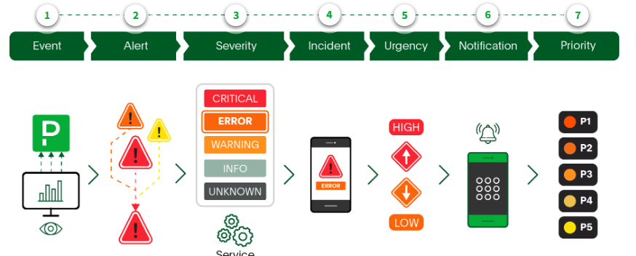

**Event**

Data is sent from any tool into PagerDuty. Events are not necessarily good or bad; they simply indicate that something has occurred in the system.

**Alert**

Event data that's been normalized Pagerduty standards.

**Severity**

Alert may contain a severity value that is based on the present rule within the monitoring tool or on the Pagerduty severity. Can be critical, error, warning, or unknown.

**Incident**

A disruption to a service prompts a notification to get sent to on-call responders. An incident may be comprised of one or more alerts.

**Urgency**

Urgency determines how Pagerduty will notify a user of an incident. Incidents can be either high or low, urgency and responses are reported differently for each urgency type

**Notification**

A message (phone call SMS text, email, or push notification) is sent to on-call responders to notify them of an issue with a service.

**Priority**

priority is a label used to classify the impact of an incident and what level of response is required the classified levels are frequently P1 to P% or SEV-1 to SEV-5 The incident priority can be set automatically at the time of incident creation using rulesets sent from a monitoring toll directly or it can be manually classified by a responded after the incident has been triggered